FALL/WINTER 2024 Flying Anvil Forge Blacksmithing Classes

Thank you for your interest in Flying Anvil Forge’s Metalworking Classes. Below you will find class descriptions, prices and scheduled dates.

FAF FAQS:
- Safety gear, materials and tools provided. Your safety is paramount. Safety precautions will be taught along with techniques. Failure to follow safety precautions may result in the student being asked to leave class.
- Bring your own snacks and plenty of drinking water.
- Cotton pants, shirts and leather closed toed shoes are required. Dress in layers, a t-shirt with a long sleeved shirt over it. Polyester clothing is a hazard.
- Class is strenuous. Be hydrated. Be rested. Be sober. Be ready.
- Classes are designed for students aged 16 & over.
- Students under the age of 16 must be accompanied by an enrolled adult.
- Children under the age of 12 are encouraged to take private one on one lessons.
- Full payment and signed liability release required to reserve a spot. Venmo, personal check & cash accepted.
- Fees refunded if cancellation is more than 48 hours previous to scheduled class.
- If you have any questions or concerns, REACH OUT! We’ll do our very best to help you. Call or text Holly (918)500-4911.

LOCATION: Flying Anvil Forge is located at 20322 HWY 75 South Mounds, OK 74047. Our driveway is on the west side of the highway less than 1/10th mile south of the HWY 75 / 201st street (Mounds/Liberty Mounds turnoff) intersection.

Basic Blacksmithing - $170 per student, 4 students max, 3 students min.
A great class for beginners who want to try blacksmithing or folks who are looking at building their skills to become knife makers or ornamental smiths. Learn the basics of forging steel using a coal forge and traditional blacksmithing tools. You'll enjoy tying knots in bars of steel with your hammer and creating your very own hand forged firepoker. Limited to 4 students. This class runs for 3 hours. This class is a prerequisite for any forged knives classes as well as Friday Open Forge nights.

FULL Saturday, October 26th 2p – 5p – FULL Ariel, Ariel’s husband paid, Brandon Moses and son
FULL Saturday, November 9th 2p – 5p – FULL Bernid– 2 spots – Paid Stephanie Bryant Simmonds paid
Saturday, November 23rd 2p – 5p - Jimmy Gwin paid
FULL Saturday, December 28th 2p – 5p FULL – Caves 1, Caves 2, Caves 3 paid, Steve McDaniels Paid
Saturday, January 4, 2025 2p – 5p
Saturday, January 18, 2025 2p – 5p
Saturday, February 1, 2025 2p – 5p
Sunday, February 16, 2025 2p – 5p
Saturday, March 1, 2025 2p – 5p
Sunday, March 9, 2025 2p – 5p
Sunday, March 23, 2025 2p – 5p
Saturday, April 5, 2025 2p – 5p

KSOs – Knife Shaped Objects - $170 per student, 4 students max, 3 students min.
This class is a great warm-up for the Intro to Forged Knives Class, we will work with low carbon steel to build our knifemaking skills before we tangle with high carbon steel (See our forged high carbon knives class) . Techniques demonstrated – Shouldering, tapering, flattering, beveling and hot-filing. Learn the basics of forging knife shapes, shouldering tangs and beveling edges while you make some useful (low carbon) knives that will dress up your cheese board or open your letters. This class runs for 3 hours. This class is best enjoyed after taking Basic Blacksmithing
Sunday, December 15th 2p – 5p – PT paid check
Sunday, January 5 2p – 5p – PT paid check
Saturday, January 25 2p -5p -
Sunday, February 2 2p – 5p –
Sunday, March 2 2p – 5p -

High Carbon Forged Knives - $225 per student, 4 students max, 3 students min.
Basic blacksmithing and KSOs class or at least 1 year of experience at the forge is a prerequisite for this class.
Let’s forge some knives! Design it, forge it, grind it, harden it, temper it and then sharpen it. Hone your knife making skills (you did see that didn’t you?) with step by step guidance to create a one-piece hand forged knife from 10-45 spring steel. Both the coal and gas forges will be lit for this hammer fest. Techniques demonstrated include: Forging high carbon steel, tapering, flattering, beveling, shouldering and heat treating
This class runs for 4 hours.
Sunday, November 24th 2p – 6p
Sunday, December 22nd 2p – 6p
Saturday, January 11th 2p - 6p
Saturday, February 8th 2p - 6p
Saturday, March 22nd 2p – 6p

Artistic Forging - $170 per student, 4 students max, 3 students min.
This class is best enjoyed after taking Basic Blacksmithing. Students with no previous experience may not get extraordinary results. Learn a few new blacksmithing skills and use them to complete a design challenge. Students are given materials, design concepts, group and one on one instruction. Everybody gets plenty of forge time, some new problem solving skills and a sweet metal work of art! Limited to 4 students. This class runs for 3 hours.
Saturday, November 16th 2p – 5p JIGS, SPRINGS & RINGS
Saturday, December 21st 2p – 5p SCROLL WORK
Sunday, January 12th 2p -5p LEAVES, FEATHERS & CHARMS
Sunday, February 9th 2p – 5p SPLITTING & DRIFTING
Saturday, March 8th 2p – 5p HOT CUT & TOP TOOLS

Forged & Heat Treated Hand Tools - $170 per student, 4 students max. 2 students min.
Basic Blacksmithing is required before enrolling in this class. An awesome tool making class – Make your own blacksmithing tools while learning the basics of tool forging and heat treating high carbon spring steel> We will make Punches, Nail sets, straight and curved chisels if time allows. We will use both the gas and coal forges, hand hammers and power hammer.
Sunday, January 26th 2p – 5p
Saturday, March 29th 2p – 5p

Rasp Knives - $120 per student, 2 students max.
No experience necessary. Transform farrier’s rasps into handmade chef’s knives. You’ll start with a 12” x 2” rasp and turn in into a culinary keepsake! This a less intensive form of making knives that does not require as much hand forging. Knives made in this class can be up to 10” long, great for a kitchen or hunting knife. Techniques demonstrated include: Forging, cutting, grinding and heat-treating high carbon steel. As well as tapering, flattering, beveling and more. Note: Knives will not have handles, make your own at your home shop out of wood, antler, bone, or otherwise. Limited to 2 students. This class runs for 2 hours.
Wednesday, January 29th 6p – 8p
Wednesday, March 12 6p - 8p

Forged Leaves, Feathers & Thingamabobs - $110 per student 2 students min. 4 students max.
No experience necessary. Create beautiful and quirky leaves, feathers and other assorted charms while you learn your way around both the coal & gas forges as well as working with smaller scale tools and techniques. Plan on taking home some neat mementoes from your experience as well as some better hammer skills! This is a 2 hour class.
Wednesday, January 22nd 6p -8p
Wednesday, February 5th 6p – 8p

Forged Roses - $185 per student 2 students max.
No experience necessary. Create a beautiful hand forged steel rose. Roses are approximately 12” long with blossoms up to 6” in diameter. We’ll texture laser cut steel plate petals and assemble them on a hand forged stem. Then we’ll fire up the torch and add shape and expression to the petals to produce a very realistic looking rose. Techniques demonstrated – Tapering, team striking, scroll work, torch sculpting, abrasion plating and more. Limited to 2 students. This class runs for 2.5 hours.
Friday, November 22nd 6p – 8:30p
Friday, December 13th 6p – 8:30p
Sunday, January 19th 2p – 4:30p

Horseshoe Hoofpicks - $110 per student, 2 students min, 4 students max.
Get your hammer on at Flying Anvil Forge and make a super sweet hoofpick out of a horseshoe. You can bring one of your horse's shoes or we'll give you a few to work with. Great for beginners who want to learn more about basic coal forging and blacksmithing. You’ll forge a super cool hoofpick that you can whip out anytime you need to pick your horse's hooves in style. This is a 2 hour class, make as many hoofpicks as you can handle!
Friday, November 8th 6p – 8p
Wednesday, January 15th 6p -8p
Wednesday, February 12th 6p – 8p

MIG Welding - $110 per student, 2 students max.
No experience necessary. Learn how to join ferrous metals with a MIG welder. We will create several free form sculptures from scrap and horseshoes as you learn and practice welding. A fast fun 2 hour class that will teach you the basics. Limited to 2 students.
Wednesday, January 8th 6p – 8p
Wednesday, March 5th 6p – 8p

Oxy Acetylene (Gas) Welding & Brazing - $110 per student, 2 students max.
Learn to weld with the basics! GAS welding is a great skill and a wonderful place to start your welding education. Learn to adjust gauges and valves to get the flame you need to weld steel with a filler rod. This is the basis of all other welding techniques and a great way to start. A fast fun 2 hour class that will teach you the basics. Limited to 2 students.
Friday, December 6th 6p - 8p
Wednesday, March 19th 6p – 8p

Open Forge - $75 per student, 4 students max, 2 students min.
SPECIAL: Save $! Prepay for 6 Open Forge sessions for $210.
Successful completion of Basic Blacksmithing is a prerequisite.
A fun few hours in the smithy for those who have taken classes at Flying Anvil Forge previously. This is a great time to forge out a project of your own design, practice your skills and have some fun. Students will be working independently but will be monitored to ensure their safety. Safety gear, SOME materials (check with us about the scope of your project) and tools provided. Gas Forge, Coal forge, MIG welder and most other tools available for use. Minimum 2 students, Maximum 4 students. This class runs for 2 hours.

Friday, November 15th 6p – 8p
Friday, December 20th 6p - 8p
Friday, January 3rd 6p – 8p
Friday, January 10th 6p – 8p
Friday, January 17th 6p – 8p
Friday, January 24th 6p – 8p
Friday, January 31st 6p – 8p
Friday, February 7th 6p – 8p
Friday, February 14th 6p – 8p
Friday, February 21st 6p – 8p
Friday, February 28th 6p – 8p
Friday, March 7th 6p – 8p
Friday, March 14th 6p – 8p
Friday, March 21st 6p – 8p
Friday, March 28th 6p – 8p

Other learning opportunities by private appointment:

Private Forge Lessons For All Ages
One on one private lesson to cover a variety of techniques. Open curriculum based on the student’s needs and skillbase. Simple to complex projects. $75 per hour.

Hammer Time– A Customized Blacksmithing Workshop Experience for Groups
No experience necessary
How about a team building experience for your staff? Maybe your Homeschoolers are itching for a field trip. Whatever your group, we are excited to design a customized entertaining and educational experience which is sure to please. Pick a date and pick a time, tell us what you’d like to accomplish and we’ll help you pick a project so everybody can have a great time and take home something they made. Your group will work in teams to create a project of your choosing: BBQ tongs, hoof picks, campfire tools, forks, ladle, steak turners and more. Your group will enjoy the setting of the blacksmith shop and learning a new skill.

Forged Steel Bangles, Cuffs and Pendants
This class is best enjoyed after taking Basic Blacksmithing. Students with no previous experience may not get extraordinary results. Forge steel bars into delicate cuff bracelets with scrolled ends, textured round bangles and simple yet elegant steel pendants. We’ll have plenty of time at the forge to create your custom designed and fitted jewelry. We will also discover the sandblaster and basic skin friendly finishes. Both gas and coal forges will be in use. Limited to 4 students.

Branding Irons
Design and forge a simple one character branding iron. We’ll coach you through every step in cutting, forging, tooling and welding a small steel brand with a forged handle made by you! Brands of course can be used for cattle, but many folks are using them to burn symbols into wood for décor, weddings, etc. Even if you’ve never even seen a cow, we’re pretty sure you’ll enjoy having your very own brand.
Campfire Tools
For beginner through advanced levels of smiths. Create cooking tripods, firepokers, cooking utensils and more for your next camping trip or bonfire. You’ll use basic blacksmithing techniques to create super cool and useful hand forged items that you can use out back. We’ll provide you with basic designs, skills and coaching all the way through. You’ll enjoy this class with its simple and useful projects. Both gas and coal forges will be in use. Limited to 4 students.

Liability Release – Next page

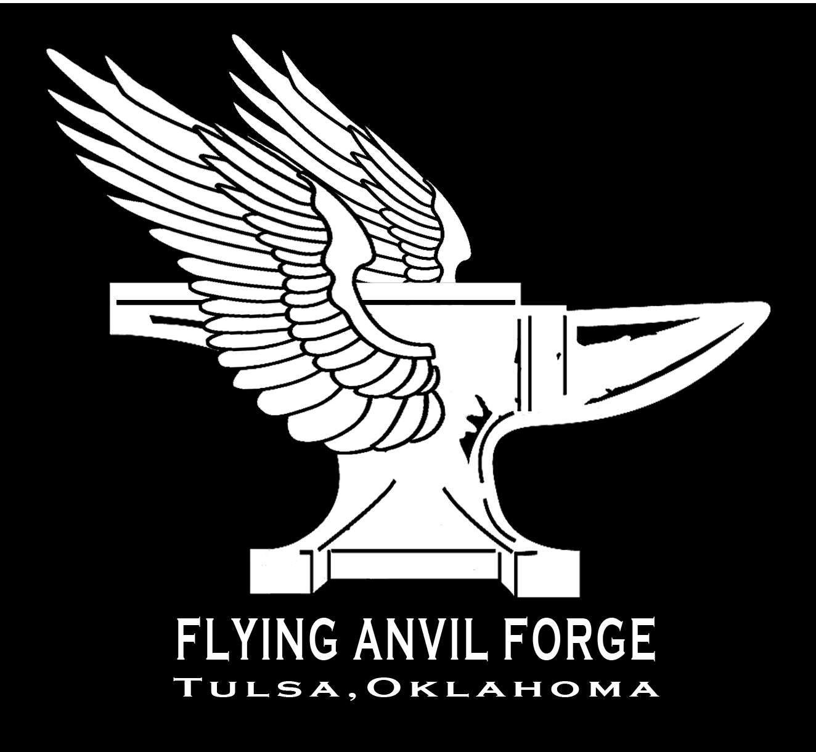

ACKNOWLEDGMENT OF RISK AND RELEASE OF CLAIMS

Dear Flying Anvil Forge Student:

On behalf of Flying Anvil Forge we welcome you to our blacksmith shop! We are very happy you are here, and are able to learn metal arts technique and theory.

The activities you may engage in while here include, but are not limited to: forging, welding, grinding, metal cutting, soldering, lifting, and moving pieces of metal, petting horses, laughing, hammering, using large, loud, powerful equipment and handling items which are very hot. Yep, it’s a blast but unfortunately, these activities carry inherent risks. At any given time, any activity can result in an injury, despite our best efforts to prevent it.

We’re letting you know know that there are such risks connected with Flying Anvil Forge activities. We urge you to be safe, be prudent, ask if you don’t know and generally, be cautious. It is your responsibility to safeguard yourself from injury.

Please acknowledge you have been made aware of the risks involved with being present in Flying Anvil Forge by signing below.

In addition, by signing below, you agree to expressly release and forever discharge Flying Anvil Forge, Anvil Ranch Farriery Inc., Holly Fisher, Olaf Batt and their agents, officers, directors, employees, successors, heirs, insurers, and assigns from all rights of action, claims, demands, and liabilities whatsoever, known and unknown, accrued and contingent, which you or your children may have against them arising from or by reason of any injuries, losses, damages, disabilities, death, suffering or results of such casualties, which have been or hereafter may be sustained by you as a result of your participation in Flying Anvil Forge programs or use of Flying Anvil Forge facilities, provided such injuries are not the result of Flying Anvil Forge sole gross negligence or willful wrongdoing.

Date: ____________________

PRINT student name: ___________________________________________

SIGN (individually or as parent of): ________________________________________

